Alabama Port Authority – Port of Mobile
Invitation to Bid

BID PURPOSE AND REQUIREMENTS FOR
BUILDING 55 INTERIOR UPGRADES – 2nd FLOOR

The Alabama Port Authority (APA) will accept sealed bids for interior upgrades to Building 55 – 2nd Floor (R) located at 1901 13th Street: Mobile, AL 36602. Building 55 is a Restricted Facility (R), as designated by the Maritime Transportation Security Act 2002 and the APA Facility Security Plan (for more information go to https://www.alports.com/port-access/ ).

This bid solicits proposals for installation of Patterned Broadloom Stain Resistant Commercial Grade Carpet & Base, installation of Waterproof High-Performance Luxury Vinyl Plank, painting of specific areas and installation of a quartz countertop with backsplash (breakroom only). Work will be in accordance with the requirements stated herein, Scope of Work Specifications, attached insurance requirements, all referenced documents and applicable State of Alabama laws. The work consists principally of providing labor, materials, equipment, insurance and supervision necessary for the work described in this bid package (floorplan and specifications attached).

The Alabama Port Authority reserves the right to terminate and amend this contract without cause nor penalty. The APA also reserves the right to reject any and all bids deemed for the interest of the APA and to strike out any item or items in the proposals, and to waive any defect or irregularity not a violation of law or to make any modification in the several conditions herein stipulated that are deemed to be in the best interest of the APA, including the separation of items of a class in making awards. In general, awards will be made to the lowest satisfactory bidder.

Requested:
Joy Lang  Fixed Assets & Service Contracts | Date
Approved:
Kelly Sims  Real Estate Manager | Date | Judith Adams  V.P. Internal & External Affairs | Date
Linda Paaymans  CFO, Secretary/Treasurer | Date | John C. Driscoll Director & CEO | Date

No allowance will be made for errors, either of omission or commission, on the part of the bidders. It must be assumed that bidders have fully informed themselves as to all conditions, requirements, and specifications before submitting proposals and they cannot expect to be excused or relieved from the responsibility assumed by their proposals on the plea of error. In case of error in extension of prices, the unit price will govern. The APA reserves the right to reject at will any employees of the Contractor to perform work on APA property.
Prospective bidders must attend a MANDATORY Pre-bid Meeting and Tour of the facility on Monday, June 20th, 2022, at 9:00 am CST. The meeting will begin in the Killian Room at the International Trade Center; 250 North Water Street; Mobile, AL 36602. Due to TWIC escort regulations, only one person per company is allowed to attend the pre-bid tour. Confirm your attendance at the mandatory pre-bid meeting to Joy Lang at joy.lang@alports.com no later than noon, Thursday, June 16, 2022. Failure to confirm your attendance may result in you not being able to attend the mandatory pre-bid meeting and tour, which is required in order to bid. Masks will be required in the van. The purpose of the meeting and tour is to allow prospective bidders to carefully examine the site of the proposed work and familiarize oneself as to the character, quality and quantities of work to be performed, and as to the requirements of the proposed contract. The submission of a proposal shall be proof that the bidder has made such examination and is satisfied as to the conditions to be encountered in performing the work and as to the requirements of the proposed contract. Prospective bidders must have a valid photo ID issued by a city, state or federal agency in order to attend the pre-bid tour.

The Contractor shall comply with all Federal and State laws, local ordinances and regulations and all orders and decrees of bodies or tribunals having any jurisdiction or authority, which in any manner affect those engaged or employed on the work, or which in any way may affect the conduct of the work.

Include in all bid proposals a copy of your City of Mobile Business license and any other appropriate licenses. Non-residents of the State must submit in their bid proposal evidence of having qualified with the Secretary of State to do business in Alabama. For bids of $50,000, or more, the bidding Contractor must include evidence of holding a current license from the State Licensing Board for General Contractors, Montgomery, Alabama, as required by Chapter 8 of Title 34 of the Code of Alabama, 1975, with the classification being Building Construction (BC) or Building Construction Under Four Stories (BCU4) Failure to enclose the specified documents in the sealed bid package will invalidate the bid. All bids over $15,000 must be notarized.

Prospective bidders must also include in their bid proposal submission a signed and notarized copy of the attached STATE OF ALABAMA DISCLOSURE STATEMENT as required by Alabama Act 2001-955. Failure to enclose the signed and notarized form in the sealed bid package will invalidate the bid. All bids over $15,000 must be notarized.

The Contractor shall place a competent superintendent on the project who shall have experience in the work being performed under the contract. The assigned superintendent shall have the responsibility for the day-to-day operations of the work and shall remain on the project site while the work under the contract is being performed. The assigned project superintendent’s cellular telephone number shall be provided to Joy Lang where she might contact the superintendent in case of an emergency. In the event the project superintendent cannot be available on any given day or week during this project, the Contractor shall name an alternate superintendent, and immediately provide that person’s cellular telephone to Joy Lang. The Contractor shall not reassign a superintendent without advance notification to Joy Lang at (251) 441-7123 or joy.lang@alports.com

Time is an essential element in this contract, as the execution of the work will inconvenience tenants and interfere with business. Therefore, it is imperative that the work be pressed vigorously to completion. The successful bidder will be required to complete the work under the contract within forty-five (45) calendar days after receipt of a “Notice to Proceed.” The work will have to be scheduled and performed in a manner that will not interfere with normal daily operations at Building 55. In addition, the cost to the APA of the administration of the contract, supervision, inspection and engineering will be increased, as the time occupied in the work is lengthened. Therefore, exclusive of Sundays and national holidays, for each day that the work remains incomplete after the time specified, an amount of $100.00 shall be paid by the contractor to the APA as liquidated damages for the loss sustained by the APA due to the failure of the contractor to complete the work within the specified time.

Sealed bid proposals must be delivered via mail courier to the Alabama Port Authority, 250 North Water Street; Suite 330; Mobile, AL 36602 any time prior to bid opening. Bids must be sealed and must state the Bid Title (“Alabama Port Authority’s Building 55 Interior Upgrades”) on the outside of the envelope. Failure to mark and/or seal the Bid Package with the Bid Title may invalidate the bid. Sealed bid proposals can also be hand delivered to the aforementioned address any time prior to the bid opening. All submitted bids will be publicly opened Monday, July 11, 2022, at 9:00 am CST in the Killian Room at 250 North Water Street, Mobile, AL. 36602. THE APA WILL NOT ACCEPT BIDS VIA EMAIL OR FAX.

Questions pertaining to this bid must be presented in writing, sent via email to Joy Lang, at joy.lang@alports.com no later than two (2) working days prior to the bid opening or will be forever waived. All answers will be posted to APA’s website.

SCOPE OF WORK TO BE PERFORMED: The scope of services for this project will include what is listed below, as well as the furnishing of all supplies, parts, materials, maintenance, service vehicles, labor, labor supervision, tools, insurance and any other special equipment necessary to provide interior upgrades of the 2nd floor of the APA’s Building 55. Before installation, the Patterned Broadloom Stain Resistant Commercial Grade Carpet and Waterproof High-Performance Luxury Vinyl Plank must be approved by the APA. Products are to have a limited ten (10) year commercial warranty against manufacturing defects and limited five (5) year finish warranty or equal. The Contractor must furnish and install new vinyl base to match. The semi-gloss (for all surfaces) and high gloss (for doors and trim) paints should include primer and is to be manufactured by Sherwin Williams or an approved equal, APA will determine the color. The successful bidder must have working knowledge of painting and carpet installation. The successful bidder must demonstrate in the bid submittal evidence of a qualified and experienced staff. Bidder shall submit a list of equipment necessary to perform the job as well as:

- Field verify all dimensions and conditions prior to construction.
- Exercise extreme care in removal of all existing construction so as not to damage construction to remain.
- Protect public spaces adjacent to the work site from any damage resulting from demolition or other work under this contract.
- Protect adjacent areas from dust due to demolition or construction.
- Coordinate all demo work and new work with Joy Lang and a point of contact at Building 55 (POC will be furnished to winning bidder).

- Secure work area.
- Paint second floor:
  - All walls and trim are to be painted in corridors.
  - Remove existing wallcovering, prep walls as required prior to painting.
  - Men’s restrooms (2) – all walls and trim to be painted.
  - Women’s restroom (2) – all walls and trim to be painted.
  - Conference room – all walls and trim to be painted.
  - Breakroom – all cabinets, walls and trim to be painted.
  - Figure 8 and Secretary Area – all walls and trim to be painted.
  - For bid additive (if awarded) – all walls and trim in off cubicle areas to be painted & installation of LVT/Carpet.
- Breakroom – remove existing countertop & backsplash and install a quartz countertop with backsplash. Remove existing tile and install Waterproof High-Performance LVT Plank.
- Figure 8 Hallway, Secretary Area & Conference Room – remove existing carpet & install new patterned broadloom stain resistant commercial grade carpet. Contractor shall patch floors as required to provide a smooth transition where existing floor is to be removed.
- Furnish and install threshold at door openings to corridors.
- Neatly place new flooring around all existing electrical receptacles.
- Keep workspace clean and remove all debris at the end of each workday.

CONTRACTOR’S RESPONSIBILITY: The Contractor shall be responsible for all damages to persons or property that occur on APA property, as a result of the contractor’s fault or negligence, as well as that resulting from acts of the Contractor’s employees, agents and subcontractors. The Contractor shall also save and keep harmless the APA against any or all lost cost, damage claims expenses or liability in connection with the performance of this contract.

PROTECTION OF THE ALABAM PORT AUTHORITY’S BUILDINGS AND EQUIPMENT: The Contractor shall use reasonable care to avoid damaging existing buildings and/or equipment on APA property. If the Contractor fails to do so and damages any such buildings or equipment, the Contractor shall replace or repair the damage at no expense to the APA. If the Contractor fails or refuses to make such repair or replacement, the Contractor shall be liable for the cost thereof, which may be deducted from the contract price.

WARRANTY OF SERVICES: Not withstanding inspection and acceptance by the APA or any provision concerning the conclusiveness thereof, the Contractor warrants that all services performed under this contract will be free from defects in workmanship and will conform to the requirements of this contract at the time of acceptance. The APA shall be given written notice of any such defect or non-conformance to the Contractor. Such notice shall state either (1) the Contractor shall correct or re-perform any defective or non-conforming services, or (2) that the APA does not require correction or replacement. If it is required for the Contractor to remove and reinstall any equipment, it shall be at no cost to the APA. If the Contractor fails or refuses to correct or replace with similar services, APA reserves the right to terminate the contract immediately at no cost to the APA. The Contractor will be held liable for any delay, loss, damage or detention caused by acts or circumstances beyond the APA’s control including, without limitation, unavailability of machinery, equipment or materials, delay of carriers, strikes, including those by Contractor's employees, priority regulations, acts of terrorism, action of the elements, forces of nature, or by any cause beyond its control. Contractors must furnish a warranty. Original manufacturer warranties are to remain in effect afterward and be assigned to APA. Contractors shall be responsible for administering all warranties on installed carpet.

CONTRACTOR TO COMPLY WITH LAWS: In the performance of this contract, the Contractor shall abide by all existing laws, codes, rules and regulations set forth by all appropriate authorities that have jurisdiction in the location where the work is to be performed. The Contractor shall also procure and pay for any necessary permits or licenses pertaining to the work hereunder.

The Contractor shall not be required under this contract to make other safety tests nor install new attachments as recommended or directed by insurance companies, federal, state, municipal or governmental authorities, not to make any replacement parts of a different design subsequent to the date of this contract, unless compensated for such installation.

PERFORMANCE BY THE ALABAMA PORT AUTHORITY:
The Alabama Port Authority agrees…
- to permit the Contractor free and timely access to areas, with the intent that work hours will be after normal business hours and/or on weekends.
- to report to the Contractor any conditions which may indicate the need for correction beyond the scope of their work.
- that the contractor does not at any time assume possession or control of any part of the carpet, but such remains the State's exclusively as the APA thereof.

PAYMENT:
All invoices shall contain the ASA issued Purchase Order Number and shall be mailed to:

Alabama Port Authority
Attn: Accounts Payable
P. O. Box 1588
Mobile, AL 36633-1588

or sent via email to accountspayable@alports.com w/Joy Lang at joy.lang@alports.com in copy.

All invoices should indicate work performed at the location in the contract and date(s) worked. Invoices should be received no later than the fifth (5th) business day of each month and net thirty (30) days payment.

Pursuant to the Code of Alabama, 1975, Title 40-23-4 (A) (11), the Alabama State Port Authority is exempt from paying taxes. An exemption letter will be furnished upon request.

IMPORTANT NOTICE TO BIDDERS REGARDING ACCESS TO RESTRICTED FACILITIES: Successful bidders requiring access to the Alabama Port Authority’s restricted facilities to fulfill any obligations set forth in this bid must comply with the Authority’s Access Policy found in its entirety at https://www.alports.com/port-access/ It is the policy of the APA that all persons (operators, supervisors, truck drivers, etc.) seeking unescorted access to port facilities must obtain an APA issued photo ID badge, an APA vehicle decal and a Transportation Worker Identification Credential (TWIC) in their possession, no exceptions. Information about the Transportation Workers Identification Credential is available online at https://www.tsa.gov/for-industry/twic or by calling 1-855-347-8371. The local TWIC Enrollment Center is located at IdentoGo at 3761 Government Blvd.; Suite E1; Mobile, AL 36693. Information on MANDATORY Security Awareness Training classes can be found at https://alabama.port.training/

IMPORTANT NOTICE TO BIDDERS REGARDING EMPLOYMENT PRACTICES: Effective October 1, 2011, the Beason-Hammon Alabama Taxpayer & Citizen Protection Act requires that any business entity contracting with or approving any grant or incentives to the state, including the APA, certify compliance with the Act. Alabama’s law requires business entities conducting business with the state register with E-Verify on or before January 1, 2012. E-Verify is an Internet-based system that allows an employer to determine the eligibility of that employee to work in the United States. The E-Verify system is operated by the Department of Homeland Security in partnership with the Social Security Administration. E-Verify is available in Spanish. All bidders must certify such compliance by executing the enclosed Certificate of Compliance with the Beason-Hammon Alabama Taxpayer & Citizen Protection Act and returning it to the APA with your bid package. The Certificate must be witnessed. For more information about this system, please log on to http://www.dhs.gov/files/programs/gc_1185221678150.shtm.

Bids will be awarded on an all or none basis unless otherwise stated. By signing this bid, I affirm the stipulated services will begin within ten (10) days from receipt of written notification to proceed by APA. Bidders must furnish with sealed bids, all insurance, City of Mobile business license and a list of all chemicals by manufacturer’s name with MSDS sheets, which must be approved by the Environmental Protection Agency and State of Alabama Agriculture and Industries, and appropriate certificates as received from federal, state and/or local agencies (to include, but not limited to, current Department of Agriculture and Industries permit), which verify qualifications to do such work listed in this bid. Bidders must also include a brief company history reflecting experience in the services listed in this bid and provide three commercial references. All bids over $15,000 must be notarized.

Bidders Submitted Price for Scope of Work:

Bidders Total Price is all- inclusive (including, but not limited to APA credentials, travel time, travel expenses, materials, warranty and insurance). The Contractor herby agrees to perform the specified work for the prices outlined below. The prices may be increased or decreased during the project execution. In the event the pricing does change, the unit price shall apply according to the scope of work.
Description | Est. Qty. | UOM | Unit Price | Value
- Insurance | LS | All | LS | $
- Removal of existing carpet & installation of patterned broadloom carpet & vinyl base – Figure 8 Hallway & Secretary Area  (includes removal & replacement of furniture) | LS | All | LS | $
- Removal of existing tile & installation of high performance waterproof LVT – Reception Area, Restrooms & Breakroom  (includes removal & replacement of furniture) | LS | All | LS | $
- Removal of existing carpet & installation of patterned broadloom carpet & vinyl base – Conference Room (includes removal & replacement of furniture) | LS | All | LS | $
- Removal of existing countertop & backsplash and installation of quartz countertop and backsplash – Breakroom | LS | All | LS | $
- Paint – Figure 8 Hallway & Secretary Area | LS | All | LS | $
- Paint – Restrooms | LS | All | LS | $
- Paint – Breakroom | LS | All | LS | $
- Paint – Conference Room | LS | All | LS | $
- Labor, Materials & Supervision  (includes cost for APA credentials) | LS | All | LS | $
TOTAL |  |  |  | $

ADDITIVE
Description – Cubicle Areas & Accounting (216) | Est. Qty. | UOM | Unit Price | Value
- Paint | LS | All | LS | $
12. Removal of existing carpet & installation of patterned broadloom carpet & vinyl base – Cubicle Areas  (includes removal & replacement of furniture) | LS | All | LS | $
12. Removal of existing tile & high performance waterproof LVT – Accounting (216)  (includes removal & replacement of furniture) | LS | All | LS | $
13.Labor, Materials & Supervision | LS | All | LS | $
TOTAL |  |  |  | $

Any additional services MUST be approved in advance by Joy Lang.

PLEASE SEE ATTACHED INDEMNIFICATION SHEET & DISCLOSURE STATEMENT
______________________________
Company

_______________________________
Representative

________________________________
Phone

________________________________
Email

FOR ALL BIDS $15,000 AND OVER
STATE OF ______________________)
COUNTY OF ____________________)

On this ___ day of ___________________ , 20___, before me appeared _________________, to me personally known, who, being by me duly sworn, did say that such person executed the foregoing instrument as the free act and deed of such person, having been duly authorized to execute such instrument in such capacity.

IN WITNESS WHEREOF, I have hereunto set my hand and official seal.

_______________________________

Notary Public, State of _____________

_______________________________
Print Name

My commission expires: ________

Receipt of following addendums is acknowledged:

Addendum No. ________
Addendum No. ________
Addendum No. ________

Contractor’s Signature:

Contractor Company:

_____________________________________________________________________

__________________________ _______________________________ ________
Name Title Date

INSTRUCTIONS FOR BIDDERS
ALABAMA PORT AUTHORITY

This instruction sheet is provided as a guide to facilitate the bid process and highlight important points for consideration by bidders. Each bidder is responsible for fully reading and complying with the instructions on the Alabama Port Authority bid form. This instruction sheet is to be used as a guide ONLY:

- Alternate bid proposals and/or suitable attachments may be rendered, with proper support.

- If your company is not prepared to submit a bid, so state and sign to avoid being deleted from the prospective bidder's list.

- The Alabama Port Authority reserves the right to reject all bids if deemed in the Alabama Port Authority's interest.

- No allowance will be made for error, either omission or commission.

- Unit price governs in errors relating to extension of prices.

- Bids will not be accepted via FAX or EMAIL. All bids must be sealed and sent via mail courier or hand delivered to APA Fixed Assets Office located in the International Trade Center Building, Suite 330; 250 N. Water St.; Mobile, AL., before the specified date and time.

- The Alabama Port Authority accepts no responsibility for facilitating the receipt of bids.

- Bid proposals must be filled out completely, including the name, address, telephone number, fax number (if possible), and signature of the responsible person.

- Please specify the bid title on envelope.

- Bids over $15,000 per year must be notarized. Notarization is not required on "SALE" bids.

- Bids received after the specified opening time will be returned to the bidder unopened. Bidders are requested to show a return address on the bid envelope.

- Questions must be submitted in writing to Joy Lang at joy.lang@alports.com

ALABAMA STATE PORT AUTHORITY

INSURANCE REQUIREMENTS FOR CONTRACT WORK

INDEMNIFICATION

The Contractor shall assume all liability for and shall indemnify and save harmless the State of Alabama and the Alabama State Port Authority, doing business as Alabama State Docks (ASD), and its officers and employees from all damages and liability for injury to any person or persons, and injury to or destruction of property, including the loss of use thereof, by reason of an accident or occurrence arising from operations under the contract, whether such operations are performed by himself or by any subcontractor or by anyone directly or indirectly employed by either of them occurring on or about the premises, or the ways and means adjacent during the term of the contract, or any extension thereof, and shall also assume the liability for injury and/or damages to adjacent or neighboring property by reason of work done under the contract

INSURANCE REQUIREMENTS
The Contractor shall not commence work under the contract until he has obtained all insurance required under the following paragraphs and until such insurance has been approved by ASD, nor shall the Contractor allow any subcontractor to commence work until all similar applicable insurance has been obtained by the subcontractor or the Contractor has provided coverage for the subcontractor. The Contractor shall provide, at his expense, insurance in accordance with the following:

General Requirements (applicable to all policies)(Required for this project)
All policies of insurance must be written with companies acceptable to ASD. The Contractor shall furnish to ASD certificates of insurance, signed by the licensed agent evidencing required coverages. ASD reserves the right to require certified copies of any and all policies. Each policy of insurance shall provide, either in body of the policy or by endorsement, that such policy cannot be substantially altered or cancelled without thirty (30) days’ written notice to ASD and to the insured. Except for Workers Compensation, said policies will identify Alabama State Port Authority, its officers, officials, agents, servants and employees as Primary and Non-contributory Additional Insureds in connection with work performed for, on behalf of, or on the property of ASD, including a waiver of all rights of subrogation.

General Liability (Required for this project)
The Contractor shall take out and maintain during the life of the contract Commercial General Liability insurance, including Blanket Contractual and Completed Operations coverages, in an amount not less than $500,000 for any one occurrence for bodily injury, including death, and property damage liability.

Automobile Liability (Required for this project)
The Contractor shall take out and maintain during the life of the contract Business Automobile Liability insurance covering any auto in an amount not less than $500,000 for any one occurrence for bodily injury, including death, and property damage liability.

Workers Compensation (Required for this project)
The Contractor shall take out and maintain during the life of the contract Workers Compensation and Employers Liability insurance providing coverage under the Alabama Workers Compensation Act in an amount not less than that required by Alabama law.

Where applicable, Contractor shall take out and maintain during the life of the contract insurance providing coverage as required by Federal statute, including but not limited to U.S. Longshoremen and Harborworkers’ Compensation Act (USL&H), Jones Act, and Railroad Federal Employers Liability Act (FELA).

State of _______________________________

County of ______________________________

CERTIFICATE OF COMPLIANCE WITH THE BEASON-HAMMON ALABAMA TAXPAYER AND CITIZEN PROTECTION ACT (ACT 2011-535, as amended by Act 2012-491)

DATE: ________________________________

RE Contract/Grant/Incentive (describe by number or subject):

_______________________________________________________________ by and between

_______________________________________________________ (Contractor/Grantee) and

_________________________________________ (State agency, Department or Public Entity)

The undersigned hereby certifies to the State of Alabama as follows:

- The undersigned holds the position of _____________________ with the Contractor/Grantee named above,
and is authorized to provide representations set out in this Certificate as the official and binding act of that entity and has knowledge of the provisions of THE BEASON-HAMMON ALABAMA TAXPAYER AND CITIZEN PROTECTION ACT (Act 2011-535 of the Alabama Legislature, as amended by Act 2012-491) which is described herein as “the Act.”
- Using the following definitions from Section 3 of the Act, select the initial either (a) or (b), below, to describe the Contractor/Grantee’s business structure.
BUSINESS ENTITY. Any person or group of persons employing one or more persons performing or engaging in any activity, enterprise, profession or occupation for gain, benefit, advantage or livelihood, whether for profit or not for profit. “Business entity” shall include, but not limited to the following:
- Self-employed individuals, business entities filing articles of incorporation, partnerships, limited partnerships, limited liability companies, foreign corporations, foreign limited partnerships, foreign limited liability companies authorized to transact business in this state, business trusts and any business entity that registers with the Secretary of State.
- Any business entity that possesses a business license, permit, certificate, approval, registration, charter or similar form of authorization issued by the state, any business entity that that is exempt by law from obtaining such a business license and any business entity that is operating unlawfully without a business license.
EMPLOYER. Any person, firm corporation, partnership, joint stock, association, agent, manager,
representative, foreman or other person having control or custody of any employment, or of any
employee, including any person or entity employing any person for hire within the State of Alabama,
including a public employer. This term shall not include the occupant of a household contracting with
another person to perform casual domestic labor within the household.

___ (a) The Contractor/Grantee is a business entity or employer as those terms are defined in Section 3 of the Act.
___ (b) The Contractor/Grantee is not a business entity or employer as those terms are defined in Section 3 of the Act.
- As of the date of this Certificate, contractor/Grantee does not knowingly employ an unauthorized alien within the State of Alabama and hereafter it will not knowingly employ, hire for employment or continue to employ an unauthorized alien within the State of Alabama.
- Contractor/Grantee is enrolled in E-Verify unless it is not eligible to enroll because of the rules of that program or other factors beyond its control.

Certified this ______day of ______________20______.
______________________________________
Name of Contractor/Grantee/Recipient

By: ______________________________________

Its: ______________________________________

The above certification was signed in my presence by the person whose name appears above, on

this______day of ________________20______.
WITNESS: ____________________________________

____________________________________
Printed Name of Witness
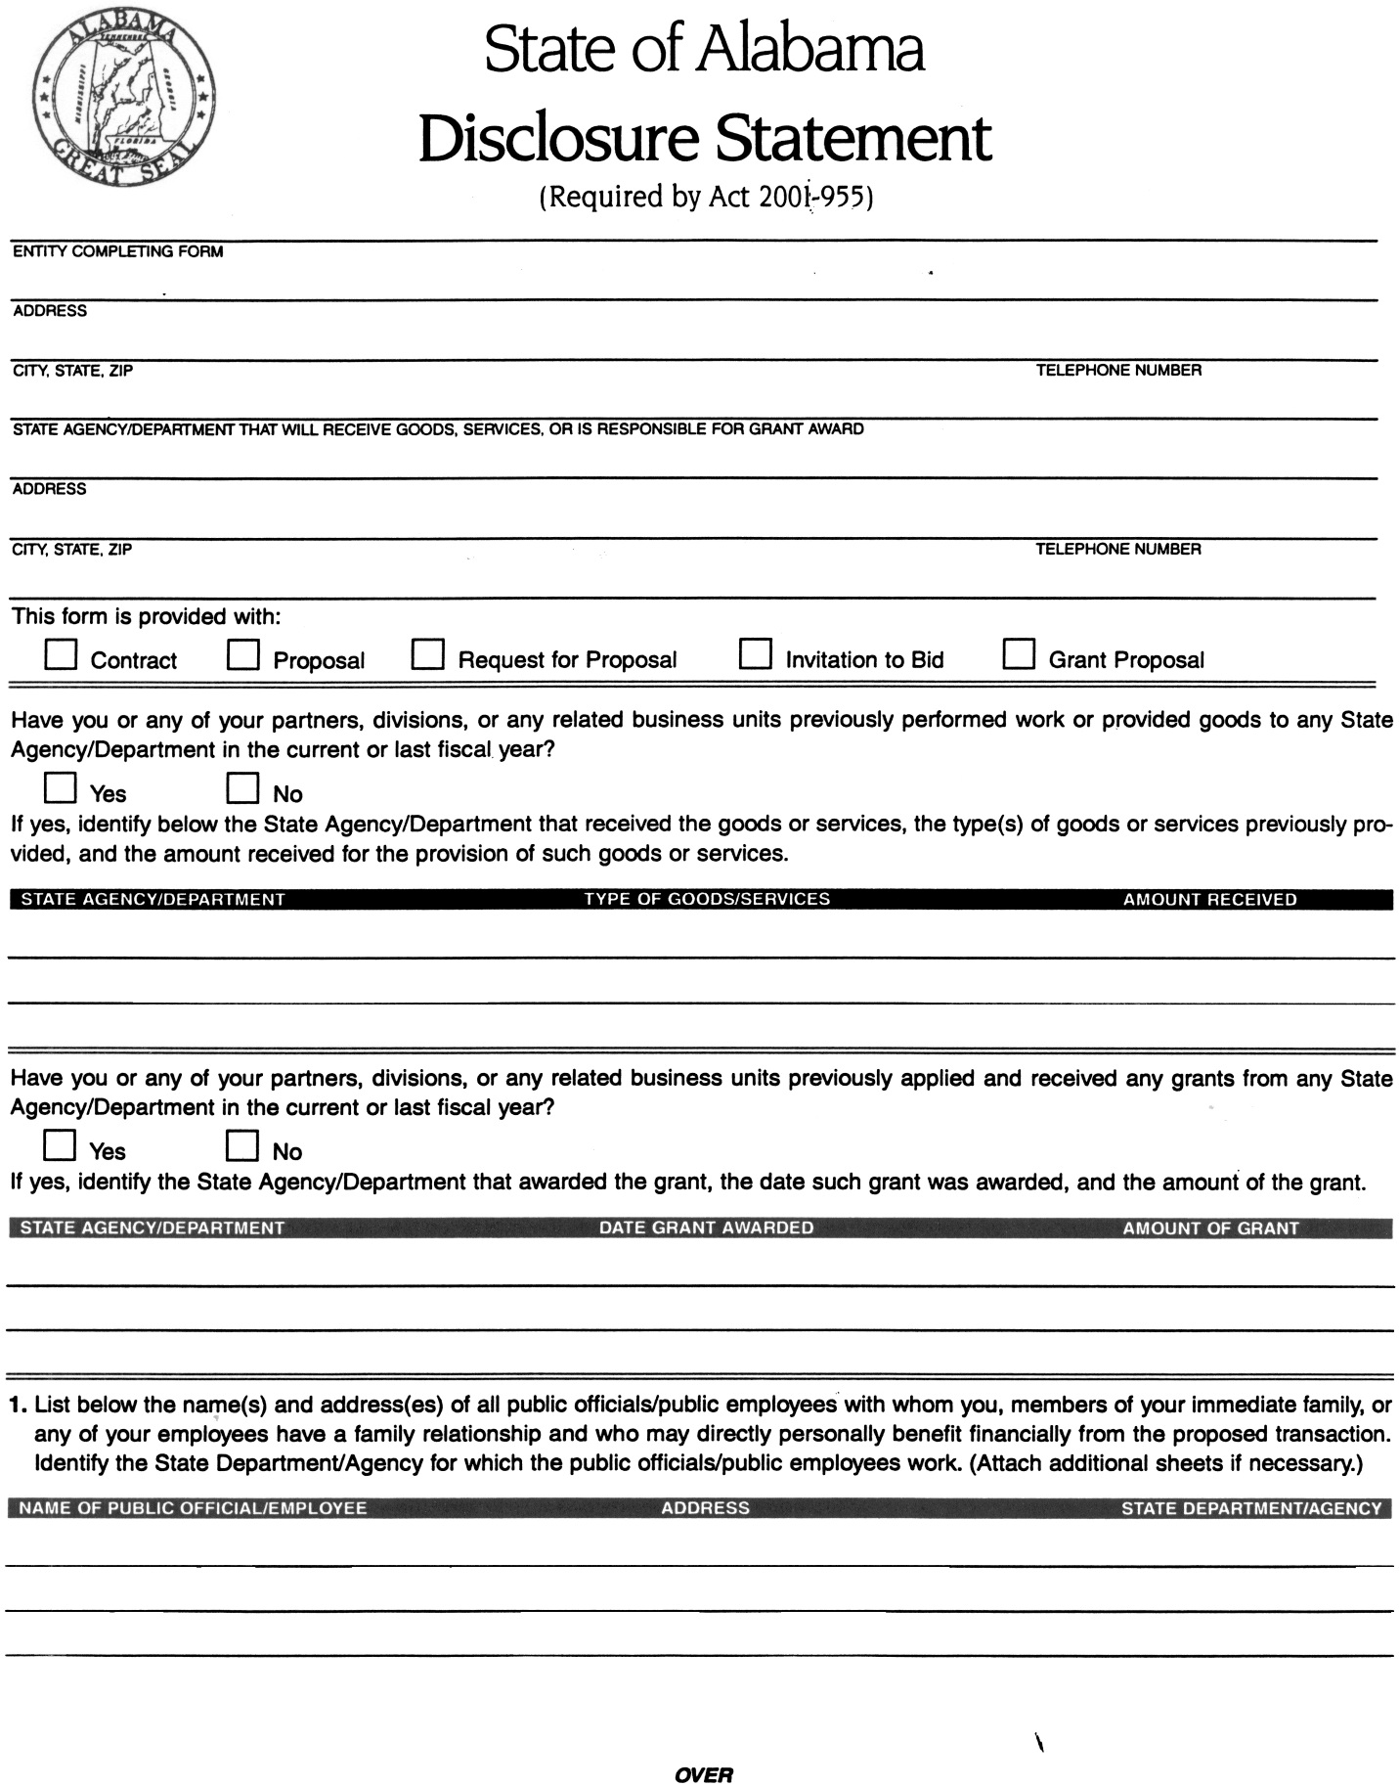

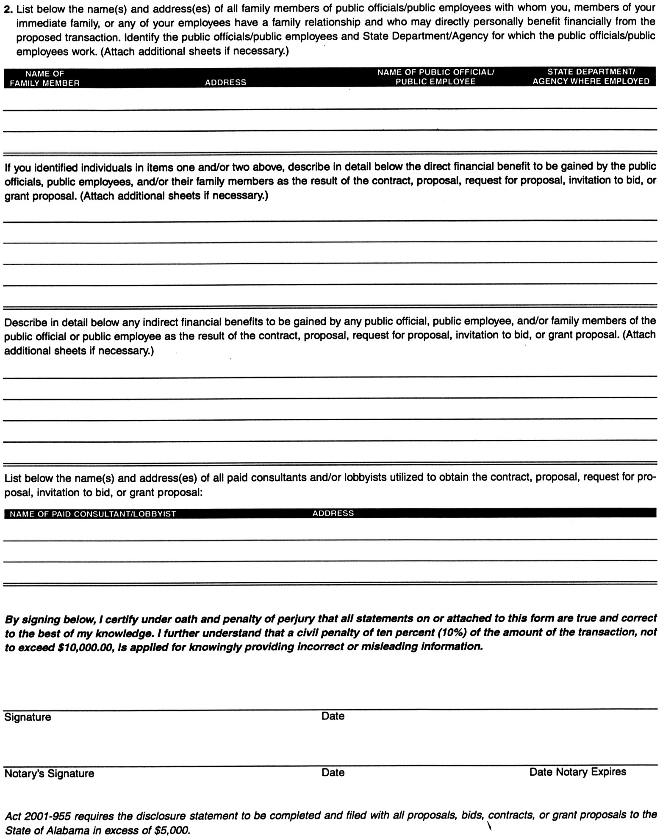

Waterproof High-Performance Luxury Vinyl Plank Specifications
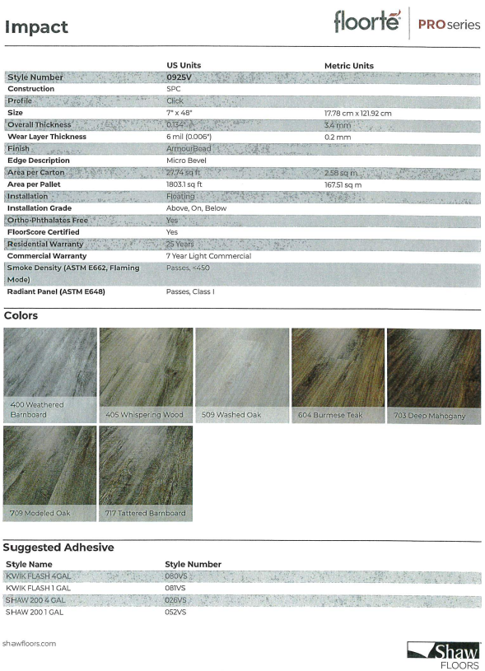
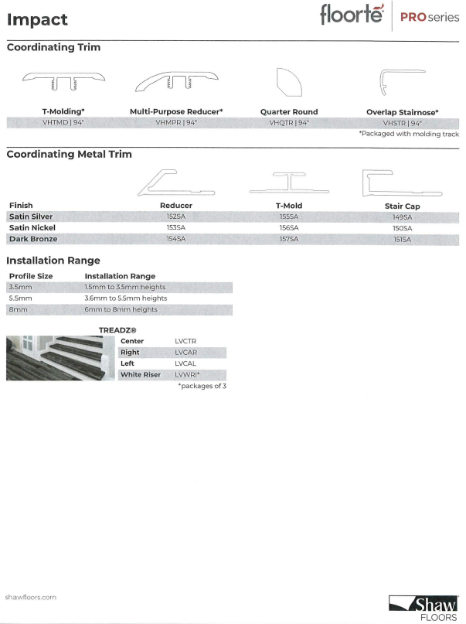
Patterned Broadloom Stain-Resistant Commercial Grade Carpet Specifications

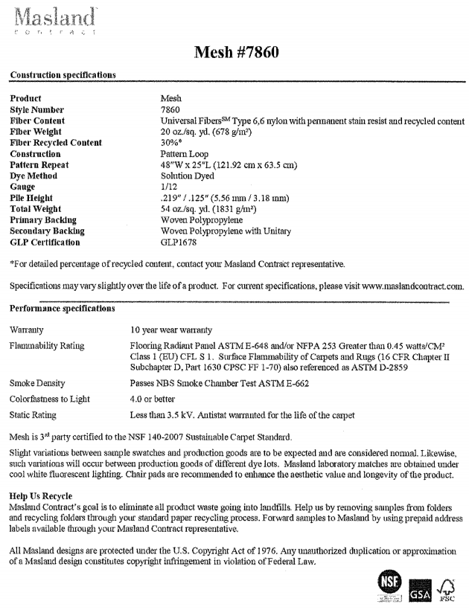
Paint Specifications
